

**FBR 102 – Auto SO Cancellation**  
Al -Talayi – Infor WM10

Functional Business Requirement

Infor10.1 SCE WM

Module Involved: scheduler/Outbound

Sequential Number 102  
for Customer:

Customer Code Al-Talayi  
or Internal:

Status: pending approval

Date Created: 19/01/2015 Document Version: V 1.0

Documented By: Charbel Azzi

# Revision History

| Revision | Reason for Change | Date | Author |
| --- | --- | --- | --- |
|  |  |  |  |
|  |  |  |  |
|  |  |  |  |

# Related Documents

| Version | Document Name | Location | Type |
| --- | --- | --- | --- |
|  |  |  |  |

# Business Requirements

Al Talayi requires a functionality that Auto Cancel inactive Shipment Orders based on specific criteria.

After the Orders are cancelled, Boomi should also send the Cancelled orders to LN.

# Required System Changes

* 1. Setup Modifications  
     1. New Job to be created under Schema > Scheduler Workbench > Job List -> New

Job Detail will be as follow:

| Description | Application Type | Type |
| --- | --- | --- |
| Auto SO Cancellation | Warehouse management | Background Job |



This will create the Job that will check the Orders..

* + 1. When creating the Job, a Class and Method should be defined.. these will be developed as per of this FBR in order to be assigned to the Auto SO JOb  
         
       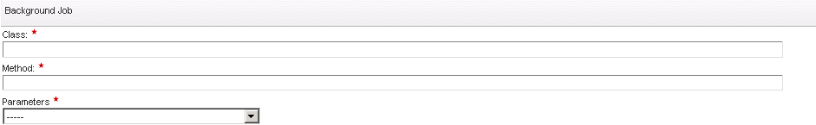
  1. Class/Method   
     1. Class Logic:   
          
        when the Job starts, the Method will run a search query on the Orders Table in order to retrieve the Inactive Orders.

The inactive orders are the Orders having the below criteria:

* SYS(date) – Orders.EDITDATE equal or more than 72 hours
* Order Type =’1’ (ORDER.TYPE=’1’)
* Storerkey=’SALES’ and ‘DAMAGE’ (ORDERS.STORERKEY)
* Orders.STATUS less or equal than **19** (Released) excel for Status 15 and 16

**Note : If Order.STATUS is equal to 15 (Part Allocated/Part Picked) or 16 (Part Allocated/Part shipped) then exclude it from the search**

If any order with matching criteria is found then system(Job) will do the following actions:

* If Order status is 11 (part Preallocated) , 12 (Preallocated) , 14 ( Part AllocateD) , 17 (Allocated ) , 19 (ReleaseD) , then Job should call the Unallocation procedure and unallocate the orders and change the Status to 99 ( Cancelled Internally) and update the OrderDetail.Openqty to 0 and OrderDEtail.STtatus to 99
* IF Order status is less than 11 (Unknown, not started, Created Externally, Created Internally …) then system should change the Status to 99 (Cancelled Internally) and update the OrderDetail.Openqty to 0 and OrderDEtail.STtatus to 99
* Create new transmit log record with Tablename = OrdercanCelled
  1. Integration Changes:

Upon Cancelling the Order, Transmitlog record will be created.

New Boomit interface will be created that will export the Cancelled Orders having Transmitlog.Transmitflag=’0’ where key1 = OrderKey that will be exported.

Below are the fields to be exported from WMS DB to Boomi DB (boomi.dbo.ST_ORDERCANCEL) (DB to DB mapping, NO XML file will be exported)

| WMS Field | Description | Boomi Table |
| --- | --- | --- |
| ORDERS.EXTERNOREDERKEY | LN Order Number | boomi.dbo.ST_ORDERCANCEL.EXTORDERKEY |
| N/A | Default Reason Code | boomi.dbo.ST_ORDERCANCEL.LNREASONCODE (To be defaulted to WMS ) |
| N/A | AddDate | boomi.dbo.ST_ORDERCANCEL.ADDDATE |
| Value to be retrieved from enterprise.WMWH_LN_Mapping.ACCENTITY | Account Entity | boomi.dbo.ST_ORDERCANCEL.ACCENTITY |

For the account entity field, the interface will map the data to be exported with the enterprise.WMWH_LN_Mapping.ACCENTITY

In the screenshot below, if ORDERS.STOREKEY=’SALES’ and ORDERS.WHSEID =wmwhse1, then ACCENTITY will be 101.

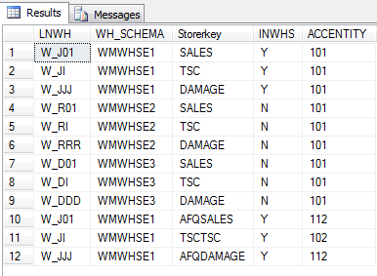

# Assumptions

* If order is picked, shipped, partially picked then no changes will be done on the Order
* Infor10 SCE Scheduler service should be in status started or else this FBR will not function.
* The Scheduler of the Export Interface to defined/set by Talayi I.T

# Unit Testing

# Impact of Change This change does not have a negative impact on the base package. On future upgrades of the base product this change will have to be accomplished again unless it is added to the base package during a future release.

# Estimate Effort

|  |  |
| --- | --- |
|  | Man Days |
| **FBR Documentation** |  |
| **FBR Development** |  |
| **FBR Testing/QA** |  |
| **FBR Deployment** |  |
| **FBR Project Management** |  |
| **Total** | **16 Days** |